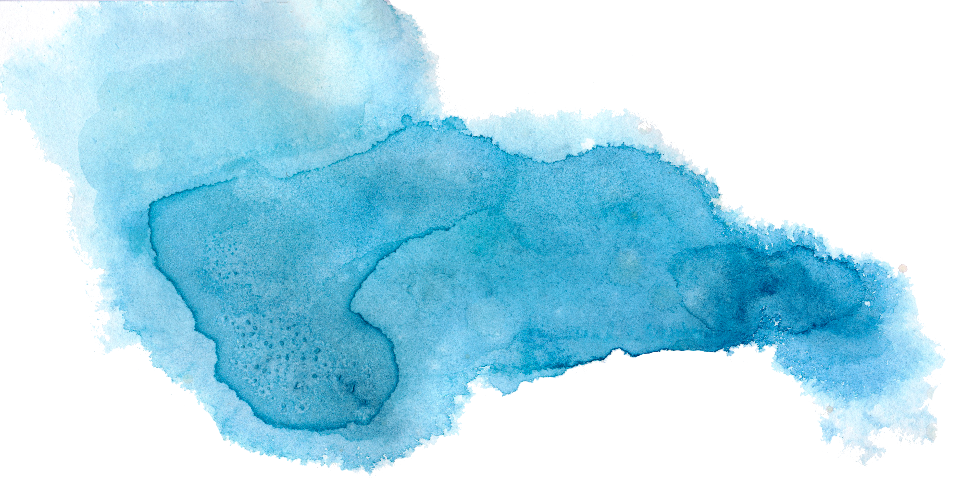

First Action Plan, Aboriginal and Torres Strait Islander Action Plan and Outcomes Framework

under the National Plan to End Violence against Women and Children 2022-2032

Stakeholder Kit

In Australia, one woman dies every 14 days at the hands of her former or current partner, and one in three women has experienced violence by an intimate partner.
Violence is disproportionately experienced by First Nations Women, who are 11-times more likely to be killed due to family violence than non-Indigenous women, and 34-times more likely to be hospitalised because of the violence.
This pack of resources is provided to help you share information about how we can end gender-based violence in one generation.
The fact that violence is still so prevalent in Australia, and the impact it has on women, children, their families and the community is a national issue on which we must act.
Under the National Plan to End Violence against Women and Children 2022-2032 (the National Plan), the Australian Government has released the First Action Plan 2023-2027, the Aboriginal and Torres Strait Islander Action Plan 2023-2025 and the Outcomes Framework 2023-2032.
For the first time, the Australian, state and territory governments have a dedicated Aboriginal and Torres Strait Islander Action Plan. It was developed in partnership with the Aboriginal and Torres Strait Islander Advisory Council on family, domestic, and sexual violence, and was informed through nationwide consultation with victim-survivors, community and sector representatives.
The Aboriginal and Torres Strait Islander Action Plan acknowledges the disproportionate levels of violence, harm and trauma suffered by Aboriginal and Torres Strait Islander women, children and gender diverse peoples. It recognises that solutions need to be led by Aboriginal and Torres Strait Islander peoples and outlines government initiatives that will focus on addressing immediate safety needs, while laying the foundations for longer term change.
The First Action Plan is a partnership between the Australian, state and territory governments, and provides a roadmap to drive the first 5-year effort towards achieving the vision of the National Plan, through 10 specific actions. The Activities Addendum of the First Action Plan lists the investments and activities that will be undertaken by the Australian, state and territory governments to implement each Action. This will be a living document, updated annually as governments progress their work to implement the First Action Plan.
The Outcomes Framework shows us where we want to be in 10 years – working towards a generational change where all Australians live free from gender-based violence and are safe at home, work, school, in the community and online. It outlines and describes the specific changes we need to strive for through the Action Plans to achieve the National Plan’s vision of ending gender-based violence in one generation.
We encourage you to share information about the Action Plans and Outcomes Framework. You play a vital role in the success of this work as an influential and trusted voice within your organisation, community and network.
By working together, we will create a safer and equal Australia for women and children.
You can read the Action Plans at: www.dss.gov.au/ending-violence

Help us spread the message
This kit contains information about the Action Plans and Outcomes Framework.

In this kit

- Website content
- Newsletter content
- Social media content
- Frequently asked questions

We encourage you to share this information with your networks. You are receiving this kit because you are a stakeholder with valuable connections in your community. By pulling in the same direction we can reach an Australia where everyone lives free from gender-based violence.

More information
To learn more about the Action Plans and the National Plan’s purpose – including how it was developed and our next steps for Women’s Safety, visit: www.dss.gov.au/ending-violence

Website content
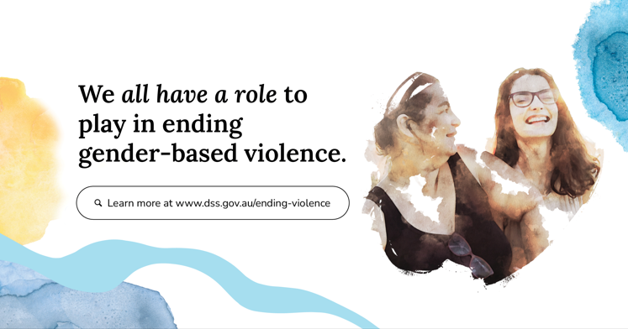
The First 5-year Action Plan, the Aboriginal and Torres Strait Islander Action Plan and the Outcomes Framework to implement the National Plan, are now available.
The Action Plans outline government initiatives aimed at preventing, addressing, and responding to violence against women and children.
These Action Plans underpin the National Plan to End Violence against Women and Children 2022–2032. The National Plan describes how all areas of society need to work together over the next 10 years to end violence against women and children.
For the first time, the Australian and state and territory governments will have a dedicated Aboriginal and Torres Strait Islander Action Plan.
The Aboriginal and Torres Strait Islander Action Plan 2023-2025 was developed in genuine partnership with the Aboriginal and Torres Strait Islander Advisory Council on family, domestic and sexual violence. It lays the foundations for longer-term structural change. It aims to address immediate safety needs of Aboriginal and Torres Strait Islander women, children and families.
The First Action Plan, together with the dedicated Aboriginal and Torres Strait Islander Action Plan, forms an integral part of commitments made in the National Plan. It provides a roadmap to drive the first 5-year effort towards achieving the vision of the National Plan. Development of the First Action Plan included specific consultation with victim-survivors, beyond the inclusion of victim-survivor expertise on the National Plan Advisory Group and the Aboriginal and Torres Strait Islander Advisory Council.
The Outcomes Framework 2023-2032 shows us where we want to be in 10 years – working towards a generational change where all Australians live free from gender-based violence and are safe at home, work, school, in the community and online. It will help track, measure, monitor, and report change over the life of the National Plan.
We all have a role to play in ending gender-based violence. By working together, we will create a safer and equal Australia for women and children.
Find out more
You can read the Action Plans and Outcomes Framework at: www.dss.gov.au/ending-violence

Newsletter content
The First 5-year Action Plan, the Aboriginal and Torres Strait Islander Action Plan and the Outcomes Framework are now available.
This work underpins the National Plan to end Violence against Women and Children 2022–2032. The National Plan describes how all areas of society need to work together over the next 10 years towards ending violence against women and children.
The Action Plans outline government initiatives aimed at preventing, addressing, and responding to violence against women and children.
This includes increasing accountability for people who choose to use violence, as well as providing person-centred and holistic responses. The responses support victim-survivors through their recovery and healing. It also includes building the workforce and strengthening data collection systems.
You can find out more at: www.dss.gov.au/ending-violence

Social media content
More social media assets will provided soon to assist in promoting the Action Plans and Outcomes Framework.
Post # 1 | The Australian Government has released the First Action Plan, Outcomes Framework and for the first time – a dedicated Aboriginal and Torres Strait Islander Action Plan to support the National Plan to End Violence against Women and Children 2022–2032.  The Action Plans outline the actions governments will take to end gender-based violence, what outcomes the actions and activities aim to achieve, and the targets we are working towards.  Learn more at: www.dss.gov.au/ending-violence  If you or someone you knows needs support regarding domestic, family or sexual violence, you can also visit 1800respect.org.au/ or call 1800RESPECT (1800 737 732). This service is free, confidential and operates 24 hours a day. | Alt text: On the right, a woman is looking towards another woman smiling. Text in the centre reads ‘We all have a role to play in ending gender-based violence.’ Text below reads ‘Learn more at www.dss.gov.au/ending-violence’. Yellow and blue water colour elements border on the left and right.
Post # 2 | We have a vision – to end gender-based violence in one generation.  The First Action Plan and Aboriginal and Torres Strait Islander Action Plan under the National Plan to End Violence against Women and Children 2022–2032 are now available.  We need a whole-of-society approach to make real change.  The Action Plans are not just for governments but for our communities, businesses and workplaces and people affected by family, domestic and sexual violence.  Learn more at: www.dss.gov.au/ending-violence  If you or someone you knows needs support regarding domestic, family or sexual violence, you can also visit 1800respect.org.au/ or call 1800RESPECT (1800 737 732). This service is free, confidential and operates 24 hours a day. | 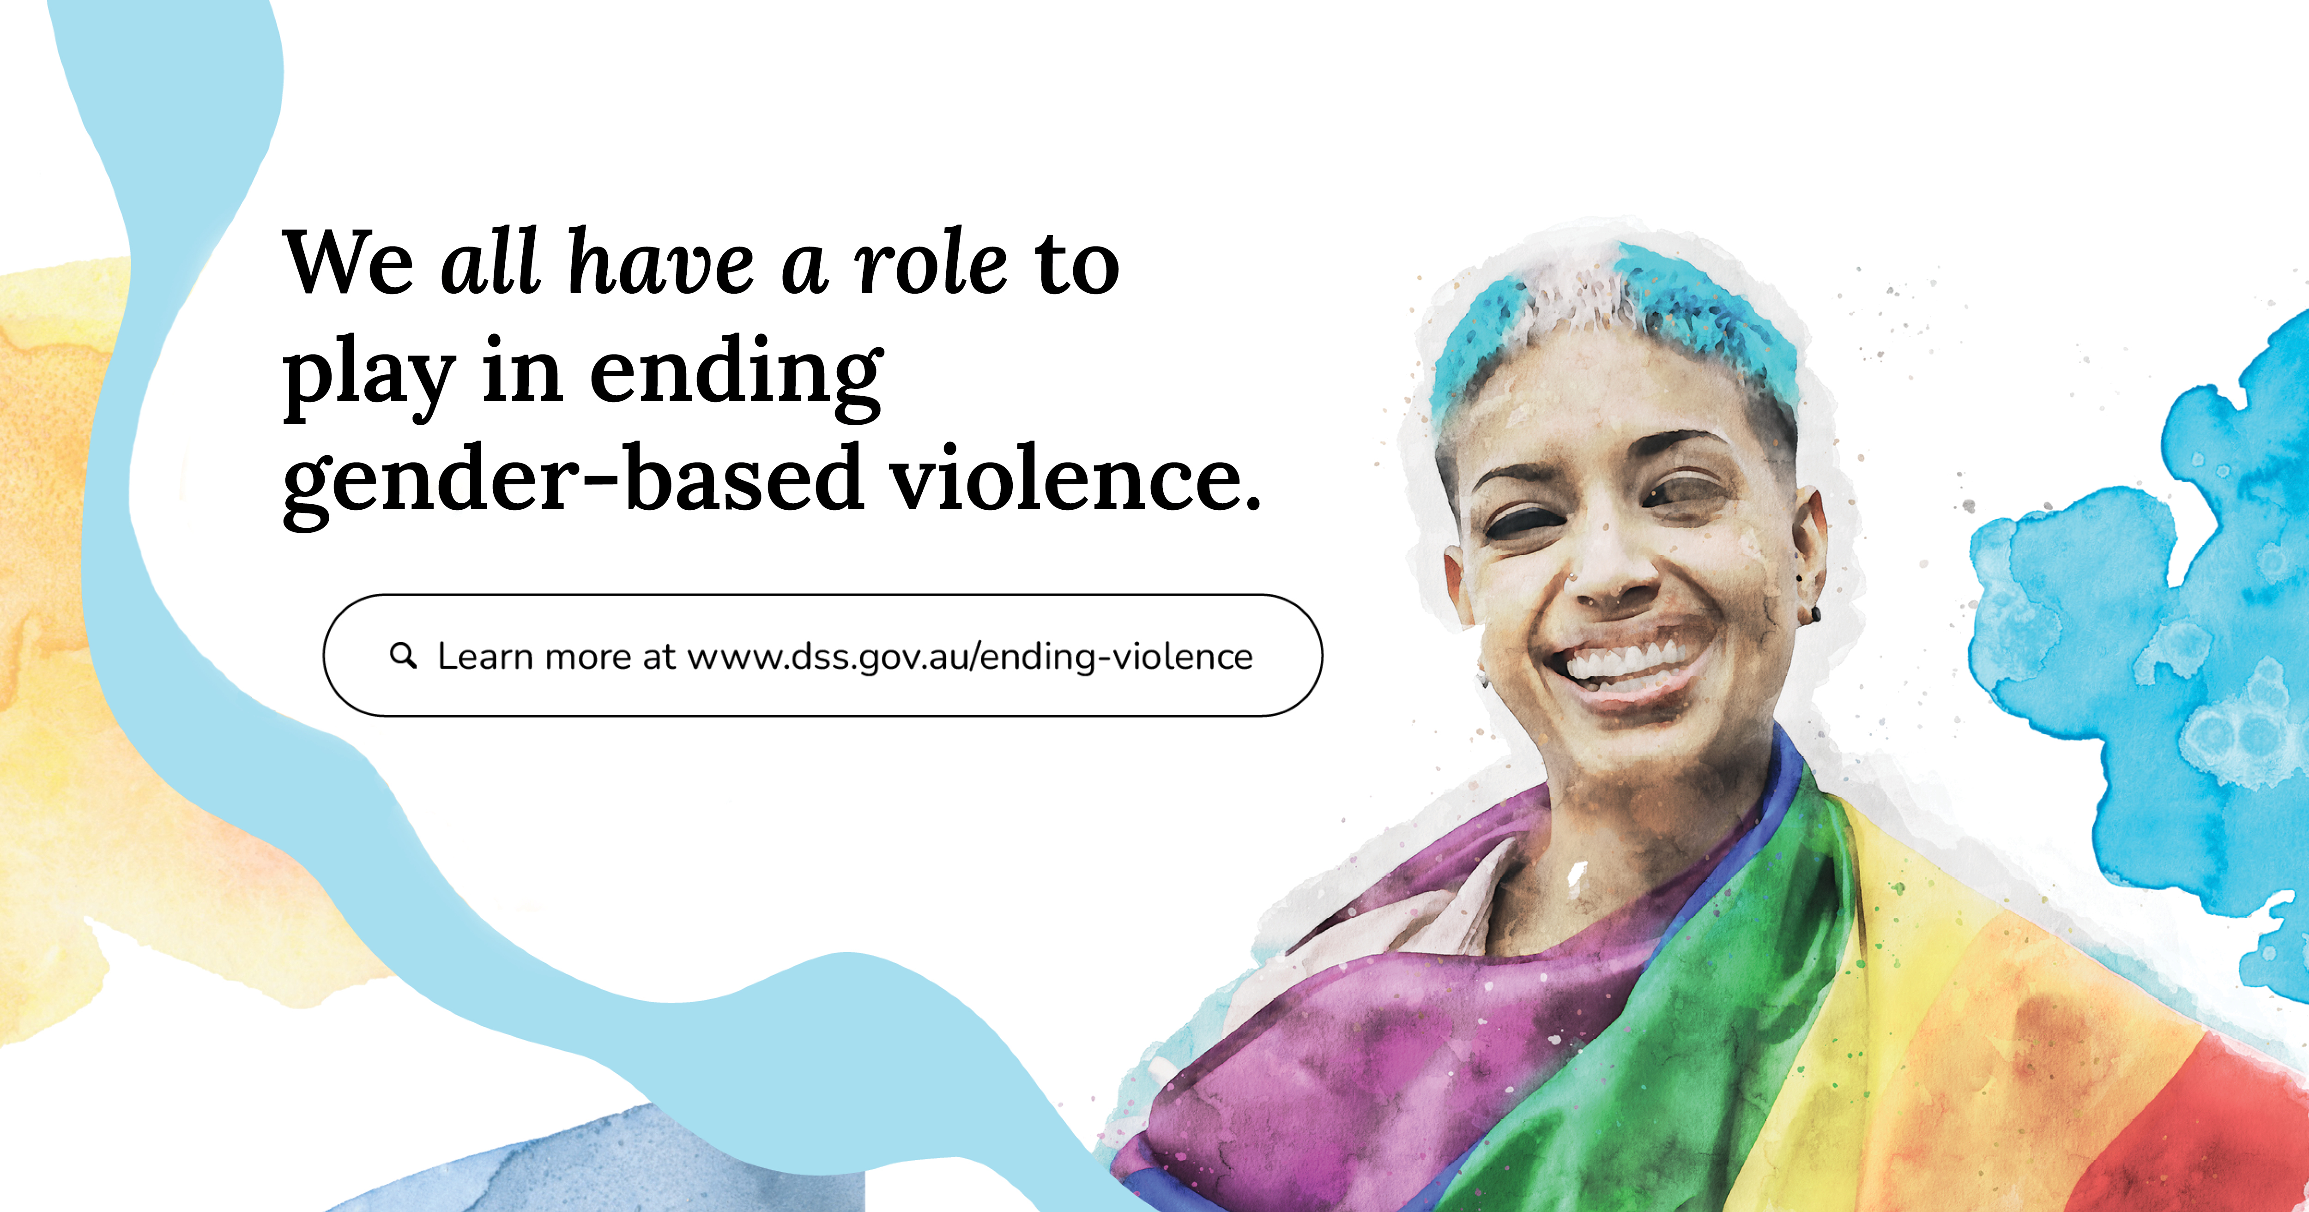  Alt text: On the right, a woman draped in a rainbow flag is smiling. Text in the centre reads ‘We all have a role to play in ending gender-based violence.’ Text below reads ‘Learn more at www.dss.gov.au/ending-violence’. Yellow and blue water colour elements border on the left and right.

Post # 3 | A dedicated Aboriginal and Torres Strait Islander Action Plan has been developed.  The Action Plan addresses Target 13 of Closing the Gap. It aims to reduce all forms of family violence against Aboriginal and Torres Strait Islander women and children by at least 50 per cent by 2031, as progress towards zero.  The Aboriginal and Torres Strait Islander Advisory Council led the development of the Action Plan.  The Action Plan will ensure a whole-of-society approach so that responses and services are culturally safe and can better meet the needs of Aboriginal and Torres Strait Islander peoples and communities.  Learn more at: www.dss.gov.au/ending-violence  Feeling worried or no good? No shame, no judgement, safe place to yarn. Speak to a 13YARN Crisis Supporter, call 13 92 76. This service is available 24 hours a day, 7 days a week. | 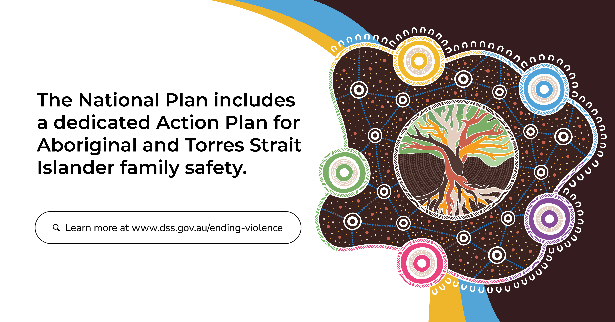  Alt text: On the right is the Action Plan artwork by Jordan Lovegrove. Artwork of a tree with yellow, blue, purple, pink and green shapes intersecting around it on a brown background. Text on the left reads ‘The National Plan includes a dedicated Action Plan for Aboriginal and Torres Strait Islander family safety’. Below, text reads ‘Learn more at www.dss.gov.au/ending-violence’.

Frequently asked questions
Why are the Action Plans and Outcomes Framework so important for communities?
- Despite the progress made, violence against women and their children remains a serious issue in Australia.
- These initiatives focus on preventing, addressing and responding to the immediate safety needs of families and communities, while laying the foundations for long-term structural change.
- There are unique challenges and additional barriers faced by Aboriginal and Torres Strait Islander women and children seeking support for family, domestic, and sexual violence, particularly within regional, rural, and remote communities.
- Activities within the dedicated Aboriginal and Torres Strait Islander Action Plan acknowledge the underlying causes of violence against Aboriginal and Torres Strait Islander peoples are different to that of non-Indigenous Australians.
- The Aboriginal and Torres Strait Islander Action Plan will be transitional. It will take effect in the short-term while the future standalone First Nations National Plan is developed.

How does the First Action Plan work?
- The First 5-year Action Plan outlines the specific actions that will contribute to achieving the outcomes of the National Plan to End Violence against Women and Children 2022–2032 (National Plan).
- The National Plan sets out the Government’s commitment to ending all forms of gender-based violence built on four National Pillars: Prevention, Intervention, Response and Recovery; informed by four foundation principles: gender equality, the diverse lived experiences of victim-survivors inform policies and solutions, Closing the Gap and intersectionality.
- The First Action Plan details specific investments, efforts and joint actions of Australian, state and territory governments to meet the objectives of the National Plan. This includes joint actions committed to by all levels of government to ensure a consistent and coordinated approach to achieving the outcomes of the National Plan.

What is the Outcomes Framework?
- The Outcomes Framework builds on the Theory of Change by providing a focus for continuous improvement through 6 long-term outcomes.
- The Outcomes Framework outlines and describes the specific changes we need to strive for through the Action Plans to achieve the National Plan’s vision of ending gender-based violence in one generation.
- The Outcomes Framework will help track, measure, monitor and report change over the life of the National Plan. It will help create opportunities for improved data collection, coordination and consistency. It will also respond to new or emerging areas of need.

Why is there a dedicated Aboriginal and Torres Strait Islander Action Plan?
- Across Australia, Aboriginal and Torres Strait Islander women, children and gender diverse people suffer disproportionate levels of violence, harm and trauma. Aboriginal and Torres Strait Islander women are 33 times more likely to be hospitalised and 6 times more likely to die from domestic violence than non-Indigenous women in Australia.
- The Aboriginal and Torres Strait Islander Action Plan lays the foundations for longer-term structural change. It aims to address immediate safety needs of Aboriginal and Torres Strait Islander women, children and families.
- Activities within the Action Plan have been developed in partnership with the Advisory Council on family, domestic and sexual violence in response to the voices of Aboriginal and Torres Strait Islander women, men, children, young people and communities that were heard throughout a comprehensive nine month consultation period.

Who was consulted in the development of the Action Plans and Outcomes Framework?
- The Aboriginal and Torres Strait Islander Action Plan was developed in partnership with the Aboriginal and Torres Strait Islander Advisory Council on family, domestic and sexual violence, and was informed through nationwide consultation with Commonwealth, states and territories, victim-survivors, community and sector representatives.
- The First Action Plan and Outcomes Framework was developed in partnership between the Commonwealth, states and territories, in consultation with victim-survivors and sector representatives.

Why the focus on ending violence against women – what about men?
- All victims – regardless of gender – need compassionate and responsive support, and all perpetrators of violence must be held to account.
- The National Plan will continue to focus on changing the harmful attitudes and behaviours that foster disrespect and allow violence to occur.
- There will also be a focus on providing the full range of support required for those who need it.
- There are a number of programs funded by the Commonwealth to support men who are affected by family, domestic and sexual violence, such as MensLine Australia, 1800RESPECT, Family and Relationship Services, Family Law Services and Family Relationship Centres. These will continue to be available in addition to other supports for women.

How will success be measured?
- A range of monitoring, evaluation and reporting activities will measure progress and impact of the next National Plan over time. This includes an Outcomes Framework, a Performance Measurement Plan and an Evaluation Plan that will assess progress against the National Plan.
- The Activities Addendum lists the investments by governments and activities that will be undertaken by the Australian, state and territory governments under each Action to achieve the Outcomes of the Outcomes Framework.
- An impact evaluation will be done at the end of 2026 to assess the achievements over the first five years of the next National Plan, and to inform the approach to the Second Action Plan. A final impact evaluation on the both Actions Plans and the National Plan as a whole will be done in 2031-32.

What support services are available?
- If you or someone you know needs support regarding domestic, family or sexual violence, you can also visit 1800respect.org.au/ or call 1800RESPECT (1800 737 732). This service is free, confidential and operates 24 hours a day.
- If you are concerned about your behaviour, call Men’s Referral Service on 1300 766 491 or visit ntv.org.au/get-help/ for judgement free support.

How can I find more information?
- For more information about the National Plan to End Violence against Women and Children, the First Action Plan, Aboriginal and Torres Strait Islander Action Plan and Outcomes Framework, visit www.dss.gov.au/ending-violence
- An Easy Read version is available to guide you through the National Plan.

