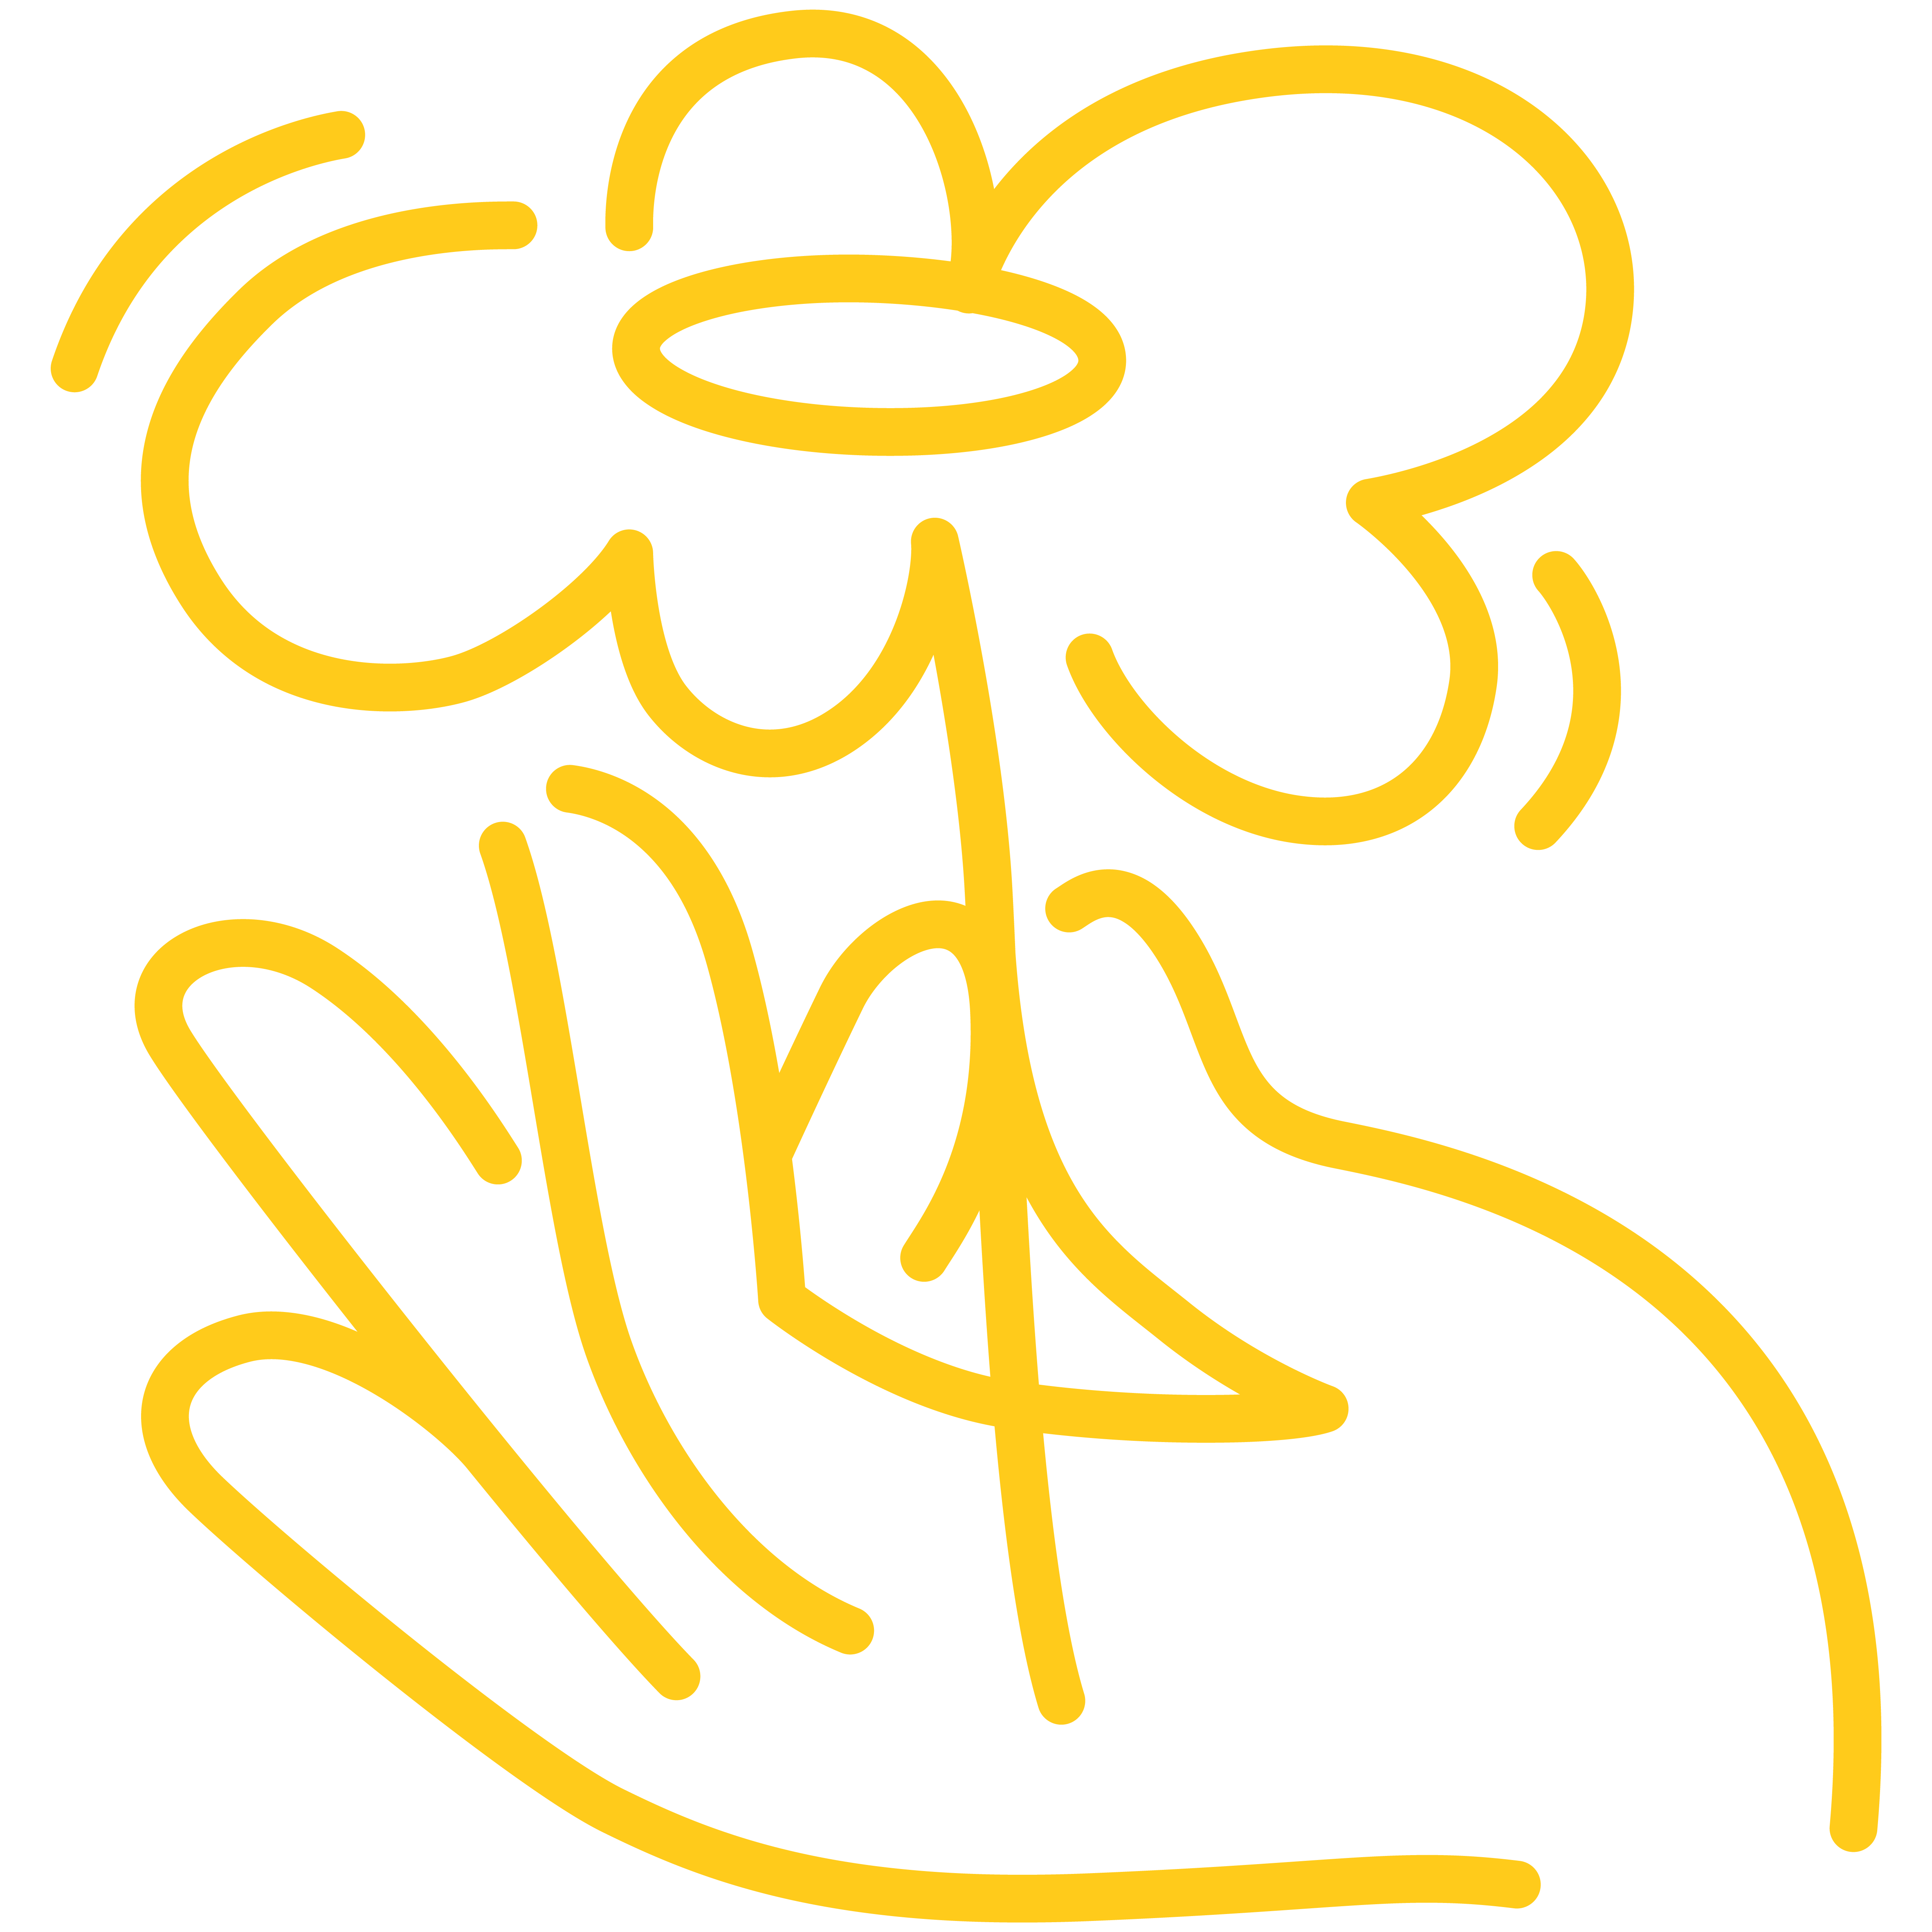

**Making   
changes   
for new beginnings**

**A therapeutic support group for women**

**Have you felt scared, intimidated, threatened or unsafe in your relationship with your partner?**

**Did you have control of your finances?**

**Has your partner blamed you for their abusive behaviour?**

Making Changes for New Beginnings is a 6 week support group for women who have experienced family violence.

The group aims to help you identify the effects of abusive relationships and create new beginnings for yourself.

Topics covered include:

* Cycle of violence
* Difference between anger and violence
* Healthy and unhealthy relationships
* Safety planning
* Parenting after family violence

**Cost**Free

**Date**

Tuesday mornings

**18th October – 29th November**

**Time**10:30am-12:30pm

**Venue**South Melbourne

**Get in touch**For more information or to book, contact Laurel on

**9690 1188**