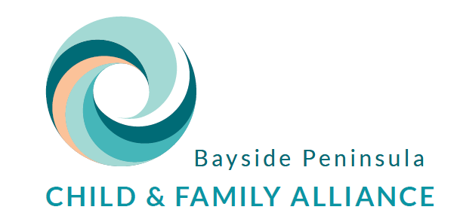
Admin Use ONLY:
Package # Date:

BP Child & Family Alliance FLEXIBLE PACKAGE REQUEST FORM
REQUESTING AGENCY DETAILS
Agency | Choose an item. | Team Leader’s Name | Click here to enter text. | Mobile No. | Click here to enter text.
 |  | Team Leader’s Email | Click here to enter text.
Program | Choose an item. | Team Leader Signature
Package type | ☐ FSP ($1028.50)  ☐ COVID provisions ($1500)
Date of Request | Click here to enter a date. | Worker’s Name | Click here to enter text.
 |  | Worker’s Email | Click here to enter text. | Mobile  No. | Click here to enter text.

Client Information
Surname: | Click here to enter text. |  |  | No. of Children: Click here to enter No.
First Name: | Click here to enter text. |  |  | Ages of Children: Click here to enter Ages.
Client ID Code: | Click here to enter IRIS / CSNet code
Has the family previously received DHHS Flexible Funding in this current financial year?  (This includes Agency FF and Alliance FF) | Yes ☒  No ☐ | If yes, Complete | Date of previous FF package provided to the family: Click here to enter a date.  Amount: $ Click here to enter amount  Description: Click here to enter text.  Rationale for subsequent FF package: Click here to enter text.  (This rationale will be recorded on the DHHS funding acquittal)
Are the family of Aboriginal or Torres Strait Island descent? | Choose Status. |  | Are the family of CALD background? |  | Choose an item.  If yes, please specify:  Click here to enter text.
Flexible Package Detail
Amount of Total Package Requested: | $Click here to enter amount  (Note maximum package amount of $1028.50)
Description of Goods or Service sought in this Flexible Support Package | Click here to enter text.
Purpose of the funding? | Choose an item.  Click here to enter text.
How do the goods and services sought in this application relate to the above purpose of the funding? | Click here to enter text.
How will these activities and or services minimise the risk factors for the children and or increase safety & wellbeing | Click here to enter text.
Goal in Action Plan best relates to: | Choose an item |  |  | IRIS Hours Recorded  Click here to enter IRIS hours
Which other funding options have been explored? | Please enter details on what other options you have explored
Purchasing instructions:
Please outline instructions for purchasing (should the application be approved). Where appropriate this should include;
- Documentation which is ready for payment (addressed to Anglicare Victoria, includes bank details, ABN) OR clear and detailed directions on what is sought as well as how and where the purchase is to be made
- Whether delivery or in store pick up is sought (if delivery; this MUST be factored into total package price)
- Client address and mobile phone number

Click here to enter text.

CHECKLIST |  |  |  |  |  | YES
COMPLETE FORM (must be fully completed)  Incomplete FSP forms will be returned to the Case Worker for completion and processing will be delayed  Client Consent Form signed and included in application (Signed consent)  Quote for Goods or Services included in application  Purchase details included |  |  |  |  |  | ☐  ☐  ☐  ☐
Please email completed document to mailto: fsalliance.bpa@anglicarevic.org.au

