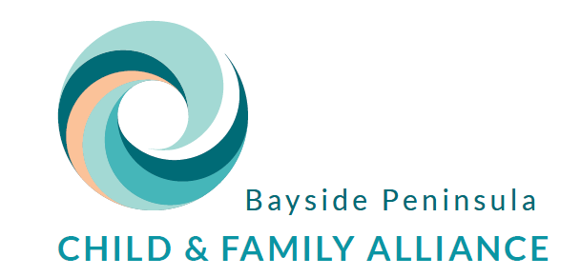

Flexible Package Application
Client Consent & Disclaimer Form

I (client name) hereby consent to (case manager name) making an application for funding on my behalf for a Flexible Support Package.

I understand that my personal information will be shared with Anglicare Victoria (who manage the funding). The Case Manager will only provide the relevant information about my family to enable the application to be considered and will tell me what information they are including on the application.
I understand that this is an application only and that funding is not guaranteed. If the Flexible Package is not approved the Case Manager may be invited to re-submit their request but the application may still be denied.
I understand that the decision making process can take up to 2 weeks from the date of submission to Anglicare Victoria, or longer should additional information or re-submission be required.
If the funding is approved, I understand that it can take approximately 2 weeks for the approved goods or services to be purchased on my behalf.

Signed ________________________________ Date ________________

